Proxy Pattern
# Source: AI Source: Provided by: [Data Path: Persons Table -> ID Column: 1, Name_En Column: Motasem Essam] -> From: [ChatGPT] on [1/23/2026]
The Proxy Pattern provides a surrogate or placeholder for another object to control access, reduce cost, or add additional functionality.
👉 Think of it like a security guard at an office: the guard decides whether someone can access the real office (the real object).

🔑 Key Points
# Source: AI Source: Provided by: [Data Path: Persons Table -> ID Column: 1, Name_En Column: Motasem Essam] -> From: [ChatGPT] on [1/23/2026]
• Controls access to the real object
• Can add lazy initialization, logging, caching, or security checks
• Client interacts with the proxy as if it’s the real object

❌ Bad Example
# Source: AI Source: Provided by: [Data Path: Persons Table -> ID Column: 1, Name_En Column: Motasem Essam] -> From: [ChatGPT] on [1/23/2026]
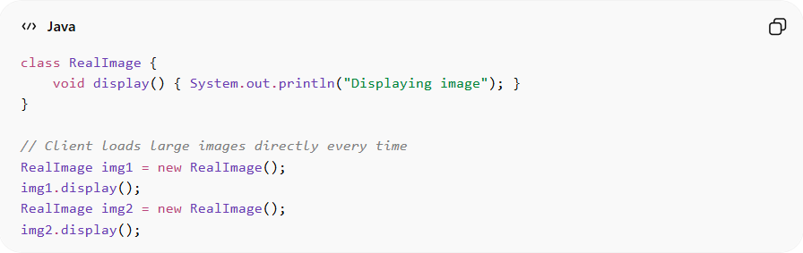
class RealImage {
void display() { System.out.println("Displaying image"); }
}

// Client loads large images directly every time
RealImage img1 = new RealImage();
img1.display();
RealImage img2 = new RealImage();
img2.display();
Problems:
• Every access loads the object immediately → inefficient
• No control over access
• Difficult to add caching, security, or logging

✅ Good Example
# Source: AI Source: Provided by: [Data Path: Persons Table -> ID Column: 1, Name_En Column: Motasem Essam] -> From: [ChatGPT] on [1/23/2026]
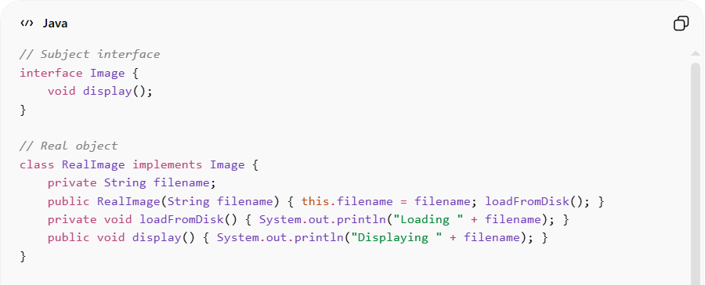
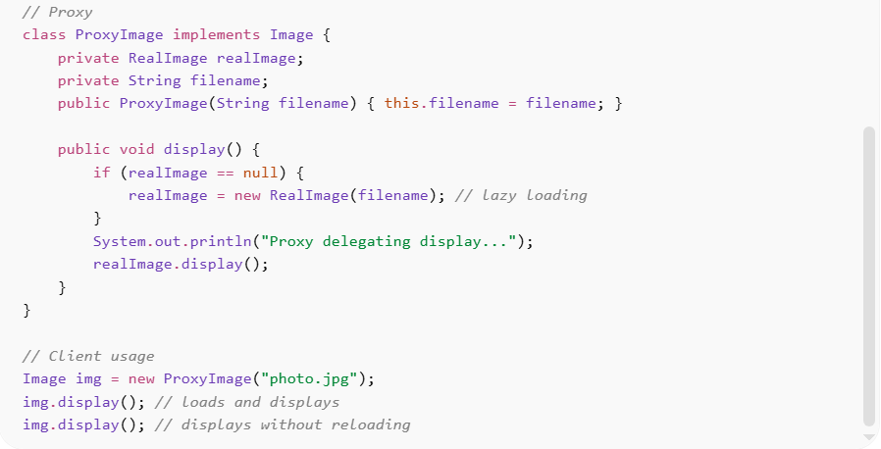
// Subject interface
interface Image {
void display();
}

// Real object
class RealImage implements Image {
private String filename;
public RealImage(String filename) { this.filename = filename; loadFromDisk(); }
private void loadFromDisk() { System.out.println("Loading " + filename); }
public void display() { System.out.println("Displaying " + filename); }
}

// Proxy
class ProxyImage implements Image {
private RealImage realImage;
private String filename;
public ProxyImage(String filename) { this.filename = filename; }

public void display() {
if (realImage == null) {
realImage = new RealImage(filename); // lazy loading
}
System.out.println("Proxy delegating display...");
realImage.display();
}
}

// Client usage
Image img = new ProxyImage("photo.jpg");
img.display(); // loads and displays
img.display(); // displays without reloading
Benefits:
• Lazy loading – object created only when needed
• Controls access and permissions
• Adds logging, caching, or security features transparently
• Client treats proxy and real object uniformly

⚡ Advantages
# Source: AI Source: Provided by: [Data Path: Persons Table -> ID Column: 1, Name_En Column: Motasem Essam] -> From: [ChatGPT] on [1/23/2026]
• Improves performance via lazy initialization
• Provides controlled access to objects
• Reduces memory footprint for heavy objects
• Enables additional responsibilities without modifying real object

⚠️ Disadvantages
# Source: AI Source: Provided by: [Data Path: Persons Table -> ID Column: 1, Name_En Column: Motasem Essam] -> From: [ChatGPT] on [1/23/2026]
• Adds extra layer of abstraction
• Can complicate code if overused
• May slightly reduce performance due to indirection

🛠️ Use Cases
# Source: AI Source: Provided by: [Data Path: Persons Table -> ID Column: 1, Name_En Column: Motasem Essam] -> From: [ChatGPT] on [1/23/2026]
• Virtual Proxy – loading heavy images or objects on demand
• Protection Proxy – controlling access based on user roles
• Remote Proxy – representing objects in a different address space (network)
• Logging or auditing – monitoring method calls without changing real object

